ECA5403-ELECTROMAGNETIC FILEDS AND WAVES
S. Rupika
192512398
C02-6

Exp no:6 Capacitance of a Parallel Plate Capacitor in Different Dielectric Media
Aim:
To write program for capacitance of parallel plate capacitor in three different dielectric medium with specific area, dielectric thickness and various dielectric constants using MATLAB.
Software required:
•MATLAB (R2018 or later)
Test case(i)
Determination and plotting of capacitance of parallel plate capacitor for given area
and dielectric thickness
Program:
clc;
clear;
A=input("Enter the area value=");
d=input("Enter the thickness value=");
epsilon0=8.854*10^-12;
C=epsilon0*A/d;
disp('The capacitance is');
disp(C);
% Plot: capacitance versus plate separation for the given area
dv = linspace(1e-3,10e-3,50);
Cv = epsilon0*A./dv;
figure;
plot(dv*1e3,Cv,'LineWidth',2); grid on;
xlabel('Plate separation d (mm)'); ylabel('Capacitance (F)');
title('Parallel plate capacitance versus separation');
% Validation using Laplace's equation (1-D finite-difference solution between the plates)
V0 = 100; N = 51; V = zeros(1,N); V(N) = V0;
for it = 1:20000
V(2:N-1) = 0.5*(V(1:N-2) + V(3:N)); % Laplace equation: d2V/dx2 = 0
end
x = linspace(0,d,N);
E = -gradient(V,x);
%
E = -dV/dx
C_lap = epsilon0*A*abs(mean(E))/V0; % C = Q/V0 with Q = epsilon0*E*A
fprintf('Capacitance from Laplace solution = %.4e F\n', C_lap);
Output:-
Enter the area value = 8e-4
Enter the thickness value = 3e-3
The capacitance is
2.36 × 10⁻¹² F
Capacitance from Laplace solution = 2.3611e-12 F
Enter dielectric constant er3 = 4
The capacitance is
3.84 × 10⁻¹² F
Output
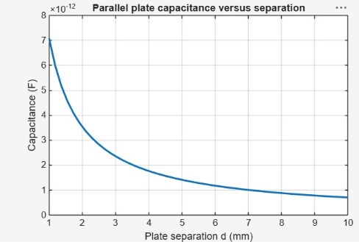
Test case (ii) Determination of capacitance of parallel plate capacitor with three different
dielectric layers
Program:
clc;
A=input("Enter the area value=");
d1=input("Enter thickness d1=");
d2=input("Enter thickness d2=");
d3=input("Enter thickness d3=");
er1=input("Enter dielectric constant er1=");
er2=input("Enter dielectric constant er2=");
er3=input("Enter dielectric constant er3=");
epsilon0=8.854e-12;
C=epsilon0*A/((d1/er1)+(d2/er2)+(d3/er3));
disp('The capacitance is');
disp(C);
OUTPUT:
Enter the area value = 8e-4
Enter thickness d1 = 1e-3
Enter thickness d2 = 3e-3
Enter thickness d3 = 2e-3
Enter dielectric constant er1 = 2.3
Enter dielectric constant er2 = 3.3
Enter dielectric constant er3 = 4
The capacitance is
3.84 × 10⁻¹² F
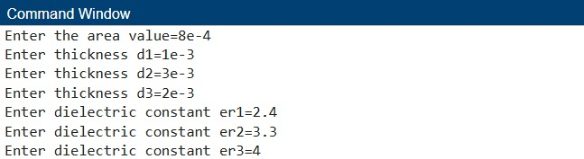
Test case (iii) Determination and plotting of capacitance variation with dielectric constant (Air)

Program:

clc;
epsilon0 = 8.854e-12;
A = 1e-4;
d = 1e-3;
er = linspace(1,1.5,100);
C = (epsilon0 .* er .* A) ./ d;
plot(er,C,'LineWidth',2);
xlabel('Dielectric constant');
ylabel('Capacitance');
title('Capacitance vs dielectric constant (Air)');
Output:-
● Capacitance increases linearly with dielectric constant

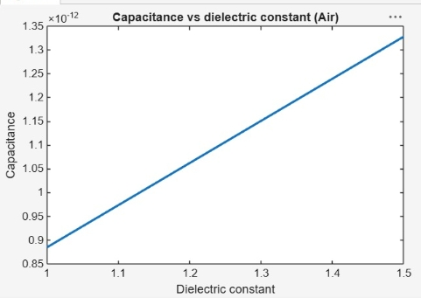
Test case (iv) Determination and plotting of capacitance variation with dielectric constant
(Glass)
clc;
epsilon0 = 8.854e-12;
A = 1e-4;
d = 1e-3;
er = linspace(4,8,100);
C = (epsilon0 .* er .* A) ./ d;
plot(er,C,'LineWidth',2);
xlabel('Dielectric constant');
ylabel('Capacitance');
title('Capacitance vs dielectric constant (Glass)');
Output:-
● Higher dielectric → higher capacitance
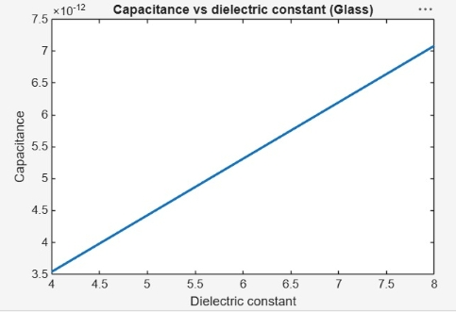
Result
Thus the program was verified for capacitance of parallel plate capacitor in different dielectric medium using MATLAB was successfully.
